**NANDHA ENGINEERING COLLEGE**

(An Autonomous Institution, Affiliated to Anna University, Chennai)

# ERODE–638052



## A Project Report

***Submitted by***

DIVYA.K ( 23AI015)

*In partial fulfillment for the award of the degree*

*of*

# BACHELOR OF TECHNOLOGY

# IN

# ARTIFICIAL INTELLIGENCE AND DATA SCIENCE

**DEPARTMENT OF ARTIFICIAL INTELLIGENCE AND**

**DATA SCIENCE**

***TABLEAU***

* *Tableau is a data visualization tool.*
* *Used for analyzing and visualizing data through interactive dashboards and reports.*
* *Allows easy creation of charts, graphs, and maps.*
* *Connects to various data sources (Excel, databases, cloud services).*
* *Helps in identifying trends, patterns, and outliers in data.*
* *Known for a user-friendly, drag-and-drop interface.*
* *Supports real-time data analysis and updates.*
* *Popular in business intelligence and data analysis fields.*

*Can be used for both individual and collaborative data analysis.*

***PROJECT TITLE*** : ***Global Beauty Trends : Synthetic Cosmetic Data Analysis***

**PROJECT OVERVIEW**

*This project involves creating an interactive Tableau dashboard to explore, analyze, and visualize synthetic data representing global beauty and cosmetics products. The dataset covers a wide range of categories like skincare, makeup, haircare, fragrances, and personal care.*

*The goal is to uncover insights into pricing trends, customer preferences, product usage behavior, and brand popularity, thereby simulating a real-world market research scenario in the beauty industry.*

*Since the dataset includes modeled prices, ratings, review counts, and usage frequency, it serves as a perfect base for building engaging visual stories and recommendation ideas.*

## *"Brand vs Number of Reviews by Product Category"*

## C:\Users\ASUS\OneDrive\Pictures\Screenshots\sheet 1.pngsheet 1

## ***What This Chart Shows :***

## *Brand vs Number of Reviews: It visualizes different beauty brands based on the total number of reviews they received.*

## *Category Breakdown: Each brand's products are further divided by product category (****like BB Cream, Blush, Foundation, etc****.) with different colors.*

## *Popularity Insight: It highlights which brands and categories are most popular based on user engagement (****through number of reviews****).*

## ***How We Built It :***

## ***Fields Used****: Dragged Brand into Rows, SUM(****Number of Reviews****) into Columns, and Category into the Color shelf to differentiate product types.*

## ***Chart Type:*** *Used a horizontal bar chart (****selected from the "Show Me" panel****) to best compare brands side-by-side.*

## ***Dataset Preparation:*** *Used the synthetic dataset, ensuring fields like Brand, Category, and Number of Reviews were properly structured*

***Purpose:***

*To analyze which brands and product categories are the most reviewed — giving an idea about customer interest, brand popularity, and product preference trends in the beauty market*

***Outcomes of the chart :***

* *Identifying Leading Brand*
* *Understanding Product Demand customer attention.*
* *Supporting Business Decisions*

## "Country of Origin Analysis Based on Beauty Product Ratings and Reviews"

## C:\Users\ASUS\OneDrive\Pictures\Screenshots\sheet 2.pngsheet 2

## ***What This Chart Shows :***

## ***Geographical Distribution****: It shows where beauty products (****brands****) originate from around the world.*

## ***Ratings and Reviews by Country:*** *The size and color intensity of the circles represent the total number of reviews and ratings from each country.*

## ***Concentration Insights:*** *Highlights key countries that dominate the beauty product market based on customer feedback volume.*

## ***How We Built It :***

## ***Fields Used:*** *Dragged Country of Origin to the view (****automatically generating Latitude and Longitude****), SUM(****Number of Reviews****) for size, and SUM(****Rating****) for color intensity.*

## ***Map Chart Selection:*** *Selected the Map chart type from Tableau's* ***"Show Me"*** *panel to visualize countries on a world map.*

## ***Visualization Settings:*** *Used circle marks where* ***size = number of reviews****, and* ***color = average ratings*** *to add a dual perspective.*

## ***Purpose:***

## *To understand the global footprint of beauty brands*

## *To identify regional strengths*

## ***Outcomes of the Chart :***

* *Top Contributing*
* *CountriesMarket Targeting,Strategic Expansion*

***"Category-wise Average Reviews by Country in Beauty Industry"***

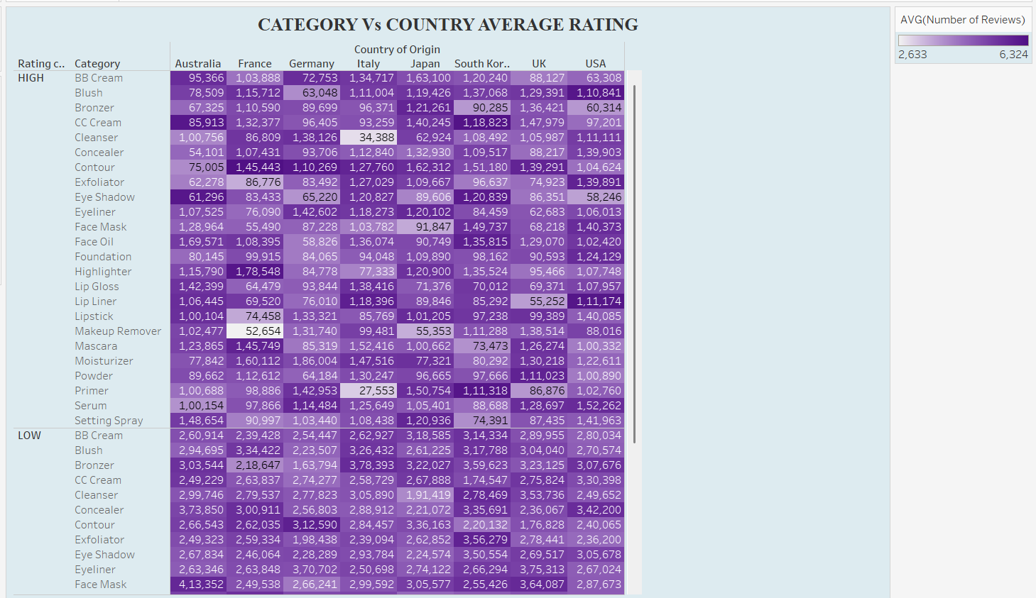

*What This Chart Shows :*

* ***Comparison Across Countries:***

*It compares the average number of reviews for various beauty product categories across different countries (****Australia, France, Germany, Italy, Japan, South Korea, UK, USA****).*

* ***Category-Based Analysis:***

*It breaks down the products by rating category ("HIGH" or "LOW") and then into detailed product categories like* ***"Concealer", "Blush", "Face Mist", etc.***

* ***Heatmap for Easy Insights:***

*The use of color intensity (****purple shades****) helps quickly spot where certain categories or countries have higher or lower engagement (****darker color = more reviews)****.*

*How We Built This Chart :*

* ***Data Preparation:***

*Loaded the synthetic dataset into Tableau and categorized by "Country of Origin", "****Rating Category****", and "****Category****".*

* ***Heatmap Visualization:***

*Chose the "Square" mark type and layered the fields in Rows (****Rating Category + Product Category****) and Columns (****Country of Origin)*** *to create a pivot-style heatmap*.

*PURPOSE :*

* *T*o analyze product engagement patterns across countries and categories.

***Outcomes / Insights of the Chart:***

* *USA dominates in the number of reviews*
* *Categories like "Concealer", "Foundation", "Lipstick" have very high engagement*
* Some countries like Australia have noticeably lower review averages etc…

***Rating vs. Price Trend Analysis for Beauty Products***

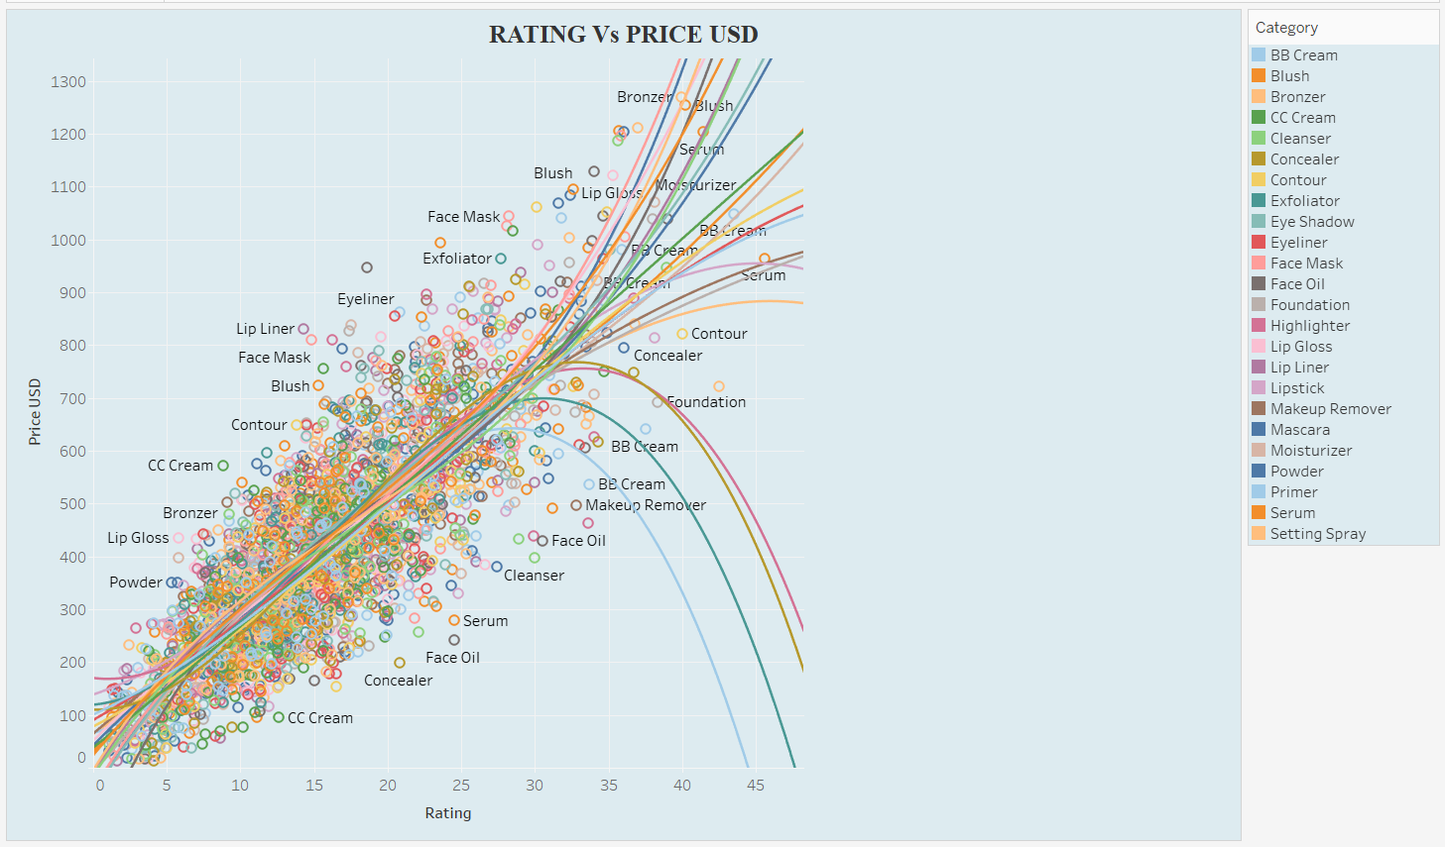

***What this chart shows :***

* ***Correlation between Price and Rating:*** *It visualizes how the price of beauty products (in USD) relates to their customer ratings across different categories.*
* ***2. Category-wise Distribution:*** *Each product category (like Serum, Blush, Foundation, etc.) is shown separately with different colors, indicating trends within categories.*
* ***3. Trend Lines per Category:*** *Curved trend lines for each category suggest how ratings behave with changes in price — for some, higher prices relate to higher ratings; for others, the relationship is non-linear*.

***How we built this chart :***

* Plotted SUM(Rating) on X-axis and SUM(Price USD) on Y-axis.
* Categorized by Product Category using color-coded dots and trend lines.
* Added trend lines to each category to visually capture rating vs. price behavior patterns.

***Purpose :***

* *To analyze whether more expensive beauty products receive better ratings.*
* *To see how different categories behave differently in terms of customer satisfaction relative to price.*
* *Useful for price positioning strategies and product value analysis in the beauty industry.*

***Outcomes / Insights of the Chart:***

* *Positive correlation for many products*
* *Certain categories deviate*
* *Pricing insights by category*

***Distribution of Beauty Products by Gender and Category***

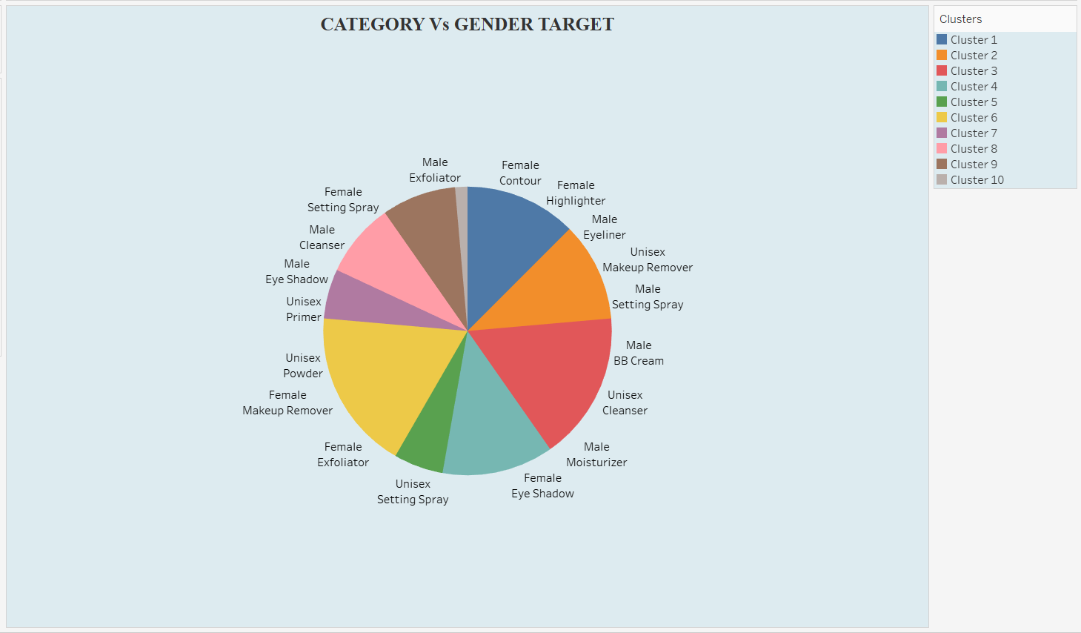

***What this chart shows:***

* *This pie chart displays how beauty product categories are distributed according to gender targeting: Male, Female, and Unisex.*
* *It highlights the percentage or count of each category aimed at specific gender groups.*
* *Categories like Foundation, Lipstick, Exfoliator, Makeup Remover, etc., are split across gender targets.*

***How we built it:***

* *Dimensions Used: Added "Category" and "Gender Target" as the main fields.*
* *Measure Used: Used the SUM(Number) to calculate the number of products per category and gender.*
* *Chart Type: Selected Pie Chart in Tableau to visually represent the gender-based division.*

***Purpose:***

* *To understand market targeting strategies by category (Male, Female, Unisex).*
* *To identify which categories are more gender-neutral versus those heavily targeted toward a specific gender.*
* *Useful for marketing strategy, product development, and consumer behavior analysis in the beauty industry.*

***Outcomes of the chart :***

* *Certain categories like Makeup Remover and Foundation have significant unisex targeting.*
* *Products like Lipstick and Highlighter are majorly targeted toward female consumers.*
* *Male-specific products appear less frequently compared to unisex and female-targeted products, showing market potential for male grooming.*

***Profit vs Price Analysis by Product Size in the Beauty Industry***

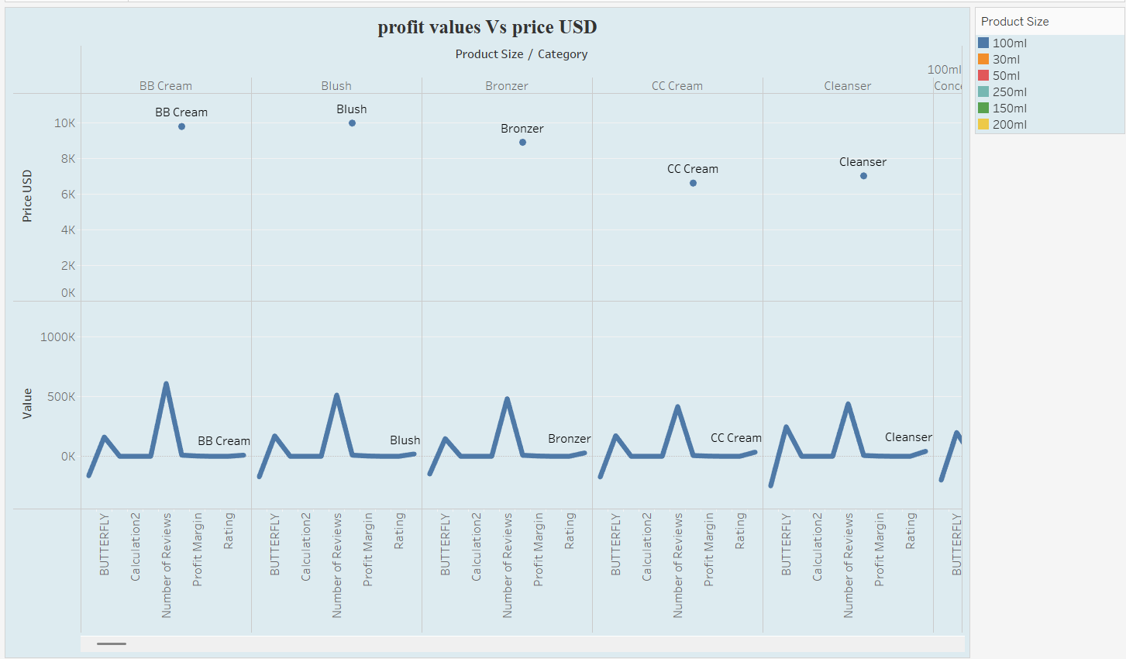

***What the Chart Shows:***

* *Chart Type: The chart is a line graph showing the relationship between product prices (USD) and profit values for different beauty product categories based on product sizes.*
* *Data Points: The product categories include BB Cream, Blush, Bronzer, CC Cream, and Cleanser, with different product sizes (100ml, 30ml, 50ml, etc.) represented by distinct colors.*
* *Trends & Patterns: The chart highlights fluctuations in profits for each product size and category, helping identify how price correlates with profit.*

***How the Chart Was Built:***

* *Data Selection: The data for different product categories and their respective prices (in USD) along with profit values were organized based on product size and category.*
* *Axes Setup: The x-axis represents product categories, and the y-axis represents profit values (in USD). Product sizes are color-coded for differentiation.*
* *Visualization Tool: A line chart was used to plot the data in a dynamic, visually appealing format, utilizing distinct colors to represent different product sizes.*

***Purpose :***

* *Market Analysis*
* *Product Strategy*
* *Trend Identification*

***Outcomes from the Chart's Database :***

* *Price-Profit Correlation*
* *Profit Fluctuations*
* *Targeted Marketing*

***Treemap Visualization of Beauty Product Review Trends***

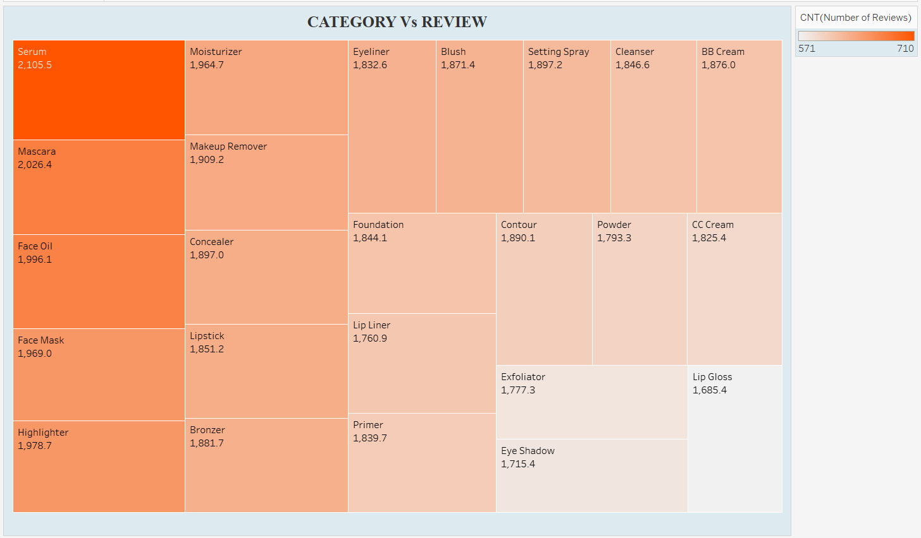

***What this chart shows :***

* *Category vs Review Relationship: It visualizes the number of reviews per beauty product category (like Serum, Mascara, Moisturizer, etc.).*
* *Popularity by Size and Color: Larger and darker colored blocks (e.g., Serum, Mascara) indicate categories with higher review counts, meaning they are more popular.*
* *Comparative Insight: It easily highlights which product types are most and least reviewed, helping spot trends at a glance.*

***How we built it :***

* *Using a Treemap Chart: The visualization type used is a Treemap where the size and color represent the number of reviews.*
* *Data Preparation: The fields "Category" and "Number of Reviews" were dragged into the visualization pane, with "Number of Reviews" aggregated (counted) and "Category" determining the split.*
* *Color Encoding: A color gradient was applied to show intensity (higher reviews = darker color), enhancing visual analysis.*

***Purpose of the chart:***

* *The purpose is to quickly identify the most reviewed (and therefore most popular or talked-about) product categories within the beauty industry dataset.*
* *It helps users, marketers, and analysts easily focus on top categories for further marketing strategies, product development, or deeper customer research.*

***Outcomes from the chart and dataset:***

* *Serums and Mascaras are the most reviewed categories (highest engagement).*
* *Products like Eye Shadow and Lip Gloss have relatively fewer reviews, suggesting lower popularity or customer engagement.*

*"****Comparative Ratings of Beauty Product Categories by Brand"***

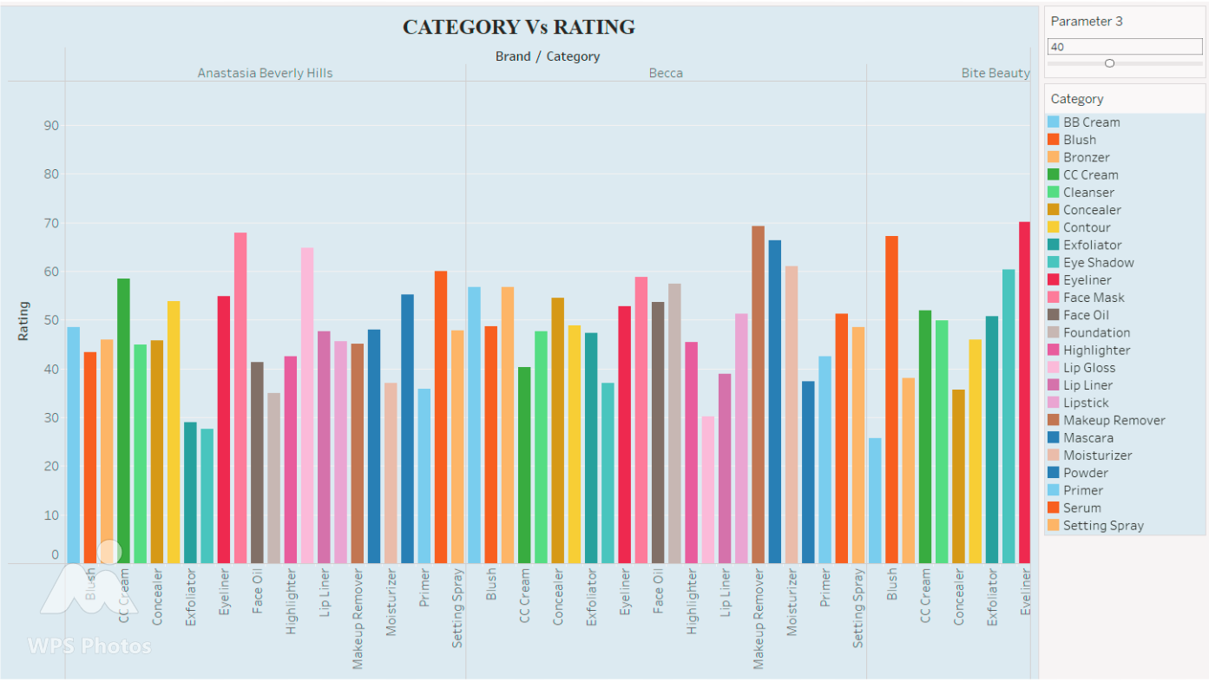

***What this chart shows*** *:*

* *Category vs Rating Comparison: It displays how different beauty product categories perform in terms of total user ratings across various brands (like Anastasia Beverly Hills, Becca, Bite Beauty, etc.).*
* *Brand and Category Insights: Each bar represents the total sum of ratings for a particular product category within a brand, giving a clear view of category strength inside brands.*
* *Category Distribution: Color coding is used for each product category, making it easy to compare multiple brands and their rated categories side-by-side.*

***How we built it :***

* *Using a Grouped Bar Chart: The visualization type is a grouped (clustered) bar chart, showing ratings grouped by both Brand and Category.*
* *Fields Added: "Brand" and "Category" are added to the columns, and "SUM(Rating)" to the rows to aggregate total ratings.*
* *Color Differentiation: The "Category" field is added to Color in the Marks card to clearly differentiate the categories in each brand section.*

***Purpose of the chart:***

* *To analyze and compare the total user satisfaction (through ratings) across different product categories and brands.*
* *It helps identify which brands are stronger in which specific categories, and overall rating performance across the beauty industry.*

***Outcomes from the chart and dataset:***

* *brands (like Anastasia Beverly Hills)*
* *High rated categories (like Blush, Eyeliner, Foundation)*

***"Product Category vs Gender Target Analysis Across Beauty Brands"***

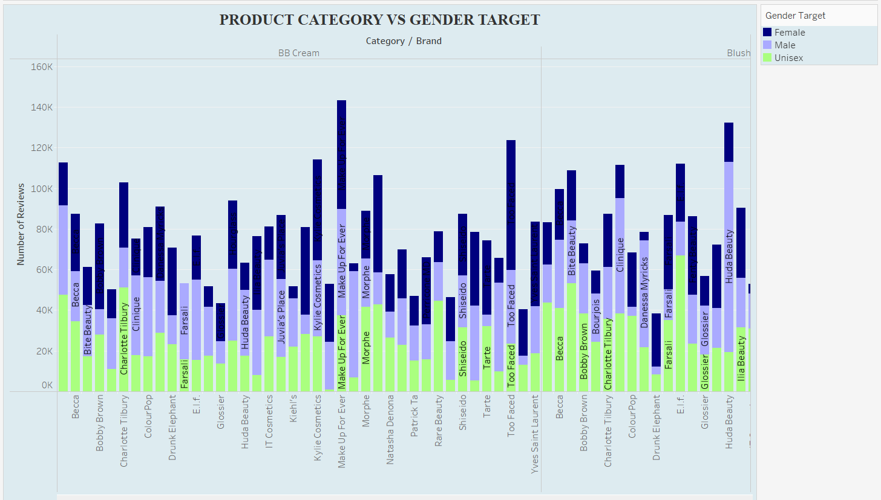

***What the Chart Shows*** :

* *Gender Target Distribution: It displays the distribution of beauty products by gender target — Female, Male, and Unisex — across different brands within categories like BB Cream and Blush.*
* *Review Volume by Gender: The stacked bar chart shows the number of product reviews based on gender targeting, giving an idea of consumer engagement levels.*
* *Brand Comparison: It compares how different brands focus their products towards specific gender groups based on the number of reviews they received.*

***How We Built It*** *:*

* *Selected Fields: Dragged Brand, Category, and Gender Target to Columns/Rows shelves in Tableau.*
* *Aggregated Measure: Used SUM(Number of Reviews) on the y-axis to measure the engagement for each combination.*
* *Stacked Bars by Gender: Added Gender Target to Color on the Marks card to split the bars into segments (Female, Male, Unisex) for visual comparison.*

***Purpose:***

* *To analyze how beauty brands target different genders and measure how much consumer attention (reviews) each target group attracts.*
* *To identify gender-oriented marketing patterns within the beauty and cosmetics industry.*

***Outcomes from the Chart Dataset:***

* *Female-targeted products dominate the beauty industry based on the number of reviews.*
* *Unisex products also show significant engagement, especially for brands like Glossier and Drunk Elephant.*
* *Male-targeted products have comparatively fewer reviews, suggesting either a smaller market share or less consumer engagement in this synthetic dataset.*

***Butterfly Chart: Gender vs Reviews in Beauty Products***

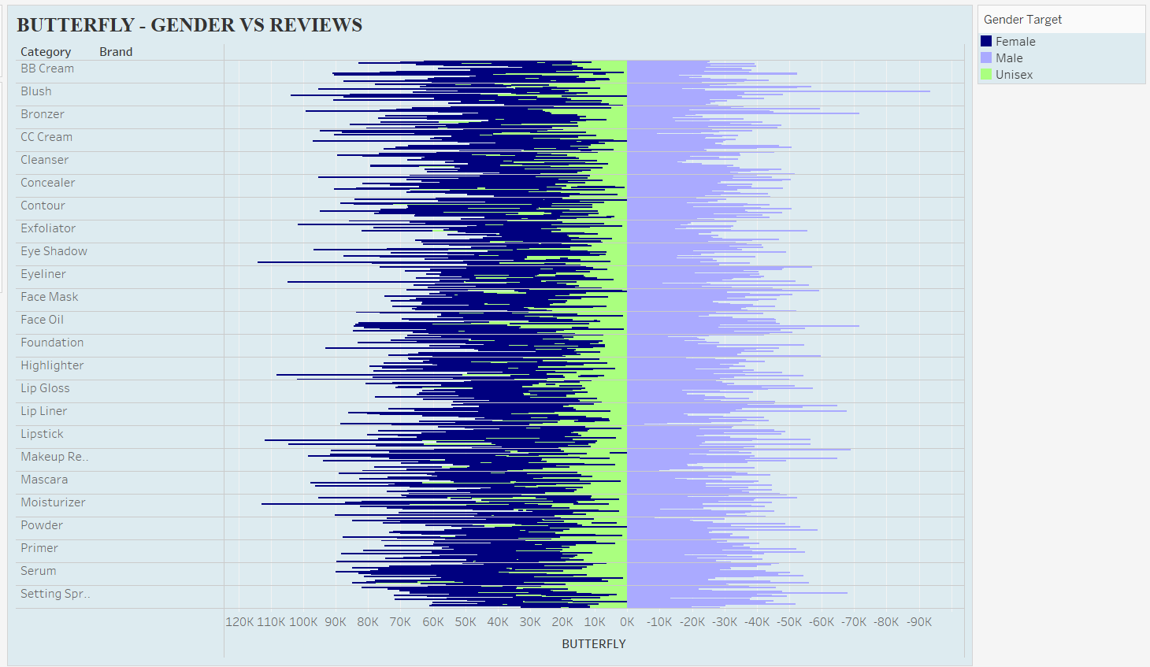

***What the Chart Shows :***

* *Gender Split Visualization: It presents a butterfly chart format where the left side shows reviews by gender (Female and Unisex) and the right side shows reviews targeted towards Males.*
* *Comparison Across Brands and Categories: Each horizontal bar represents the review volume for brands within different beauty product categories.*
* *Product Popularity by Gender: It helps to quickly spot the gender*

***How We Built It :***

* *Measure Selection: Used the SUM of BUTTERFLY field (a calculated field) for plotting review counts.*
* *Fields Placement: Placed Category and Brand on Rows, and used the custom calculated measure on Columns to create the butterfly (positive for Female/Unisex, negative for Male).*
* *Gender Target Coloring: Dragged Gender Target into the Color mark*

***Purpose:***

* *To visually separate and compare review engagement between male-targeted and female/unisex-targeted beauty products.*

***Outcomes from the Chart Dataset:***

* *Female-targeted products have a significantly higher number of reviews than Male-targeted ones, confirming a major focus on the female market.*
* *Unisex products are also strong in reviews, indicating broad consumer appeal beyond strict gender divisions.*

*Male-targeted products show relatively lower engagement*

***Waterfall Chart: Price Flow by Category***

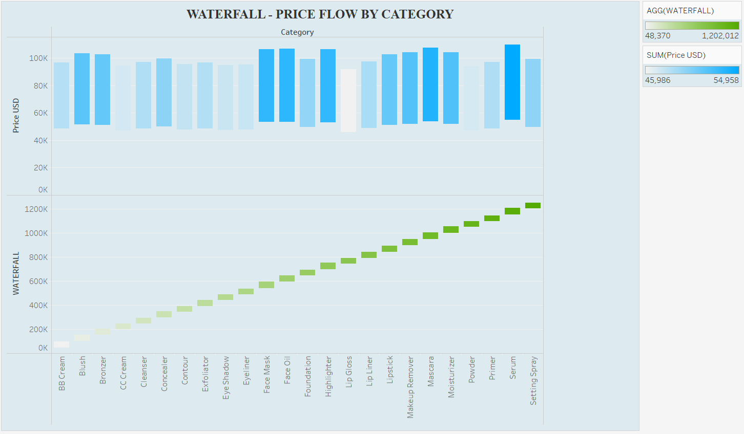

***What the Chart Shows :***

* *Price Distribution Across Categories: It visualizes the total price accumulation across different product categories like Blush, Bronzer, CC Cream, etc.*
* *Cumulative Pricing Effect: The green bars at the bottom show how each category contributes cumulatively to the total sum of prices.*
* *Category Comparison: The blue bars at the top allow easy comparison of individual category price totals side-by-side.*

***How We Built It :***

* *Measure Selection: Used SUM(Price USD) to plot individual category prices, and a calculated field WATERFALL to create the cumulative effect.*
* *Fields Placement: Category placed on Columns, and multiple measures (SUM(Price USD) and WATERFALL) on Rows to form the two layers .*
* *Dual Axis & Synchronization: Merged both measures on a dual-axis chart and synchronized axes*

***Purpose:***

* *To analyze price flow across categories and identify which categories have higher or lower average pricing.*
* *To visualize cumulative contribution to the total market price based on price volume.*

***Outcomes from the Chart Dataset:***

* *Higher-priced categories such as Foundation, Face Oils, and Serums stand out clearly, contributing heavily to the total simulated market value.*
* *Lower-priced categories like Blush and Eyeliner contribute much less individually.*
* *The overall flow is steady, but there are some sharp rises at certain categories indicating premium segments in beauty products.*

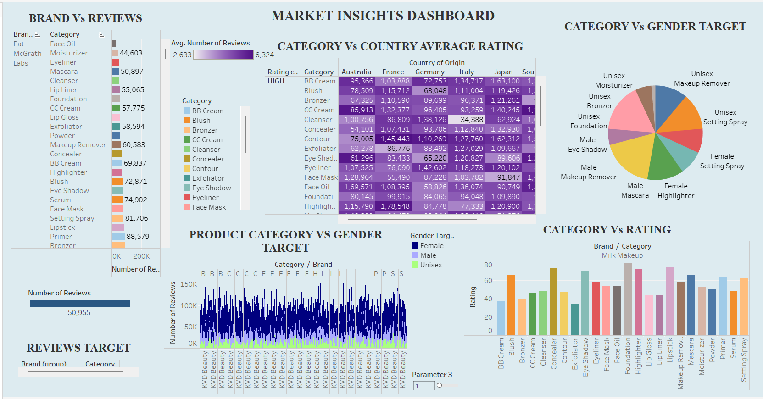

***OVERVIEW OF DASHBORAD***

*This dashboard provides a complete analysis of the beauty and cosmetics market (from the synthetic dataset) focusing on brand performance, product category performance, consumer targeting by gender, and international trends based on country-wise ratings and reviews.*

*The main goal is to identify trends, understand customer behavior, and benchmark product categories and brands for smarter business decisions.*

***Overall Analysis & Key Insights:***

* *Top Performing Brands:Brands like Pat McGrath Labs have the highest number of reviews, showing strong customer engagement.*
* *Category Popularity:Foundation, Serums, and Face Oils are among the highest-rated and most reviewed product categories.*
* *Country Insights:Japan and France show the highest average ratings, suggesting strong customer satisfaction in these markets.*
* *Gender Target Trends:Most products are targeted as unisex, making them more versatile and widely accepted across genders.*
* *Rating Patterns:Categories like Lip Gloss, Highlighter, and Mascara consistently score good ratings, pointing to customer favorites.*
* *Review Distribution:Review volumes are higher for products that cater to both male and female audiences, not just one.*
* *Strategic Focus:To grow, brands should focus on popular categories,unisex products.*

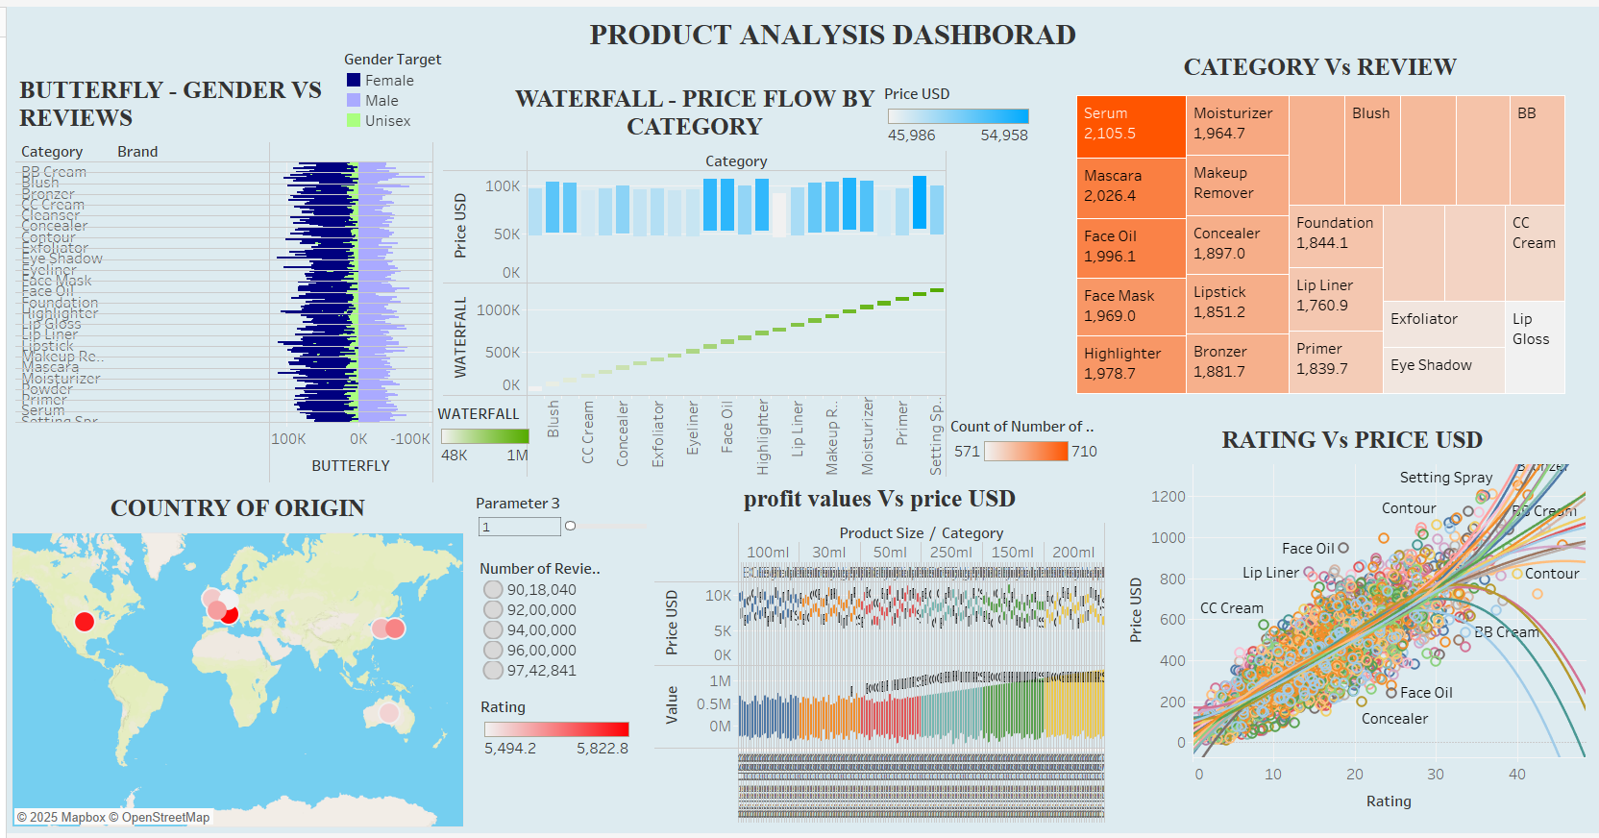

***Dashboard Overview:***

*This dashboard analyzes beauty product categories, prices, reviews, gender targets, and country of origin.It focuses on how different product attributes like price, review count, profit values, and ratings relate to one another.*

*The dashboard provides a complete view of product dynamics across multiple factors like price, profit, rating, gender, country, and category, helping in identifying key drivers of market success.*

***Overall Analysis & Key Insights:***

* *Price Flow Across Categories:The Waterfall Chart shows how product prices vary category-wise, helping to easily spot high and low-priced categories.*
* *Review Distribution by Category:The Category vs Review treemap highlights that products like Serums, Moisturizers, and Face Oils have higher review counts etc…*
* *Gender Target Analysis:The Butterfly Chart reveals that most product reviews are dominated by Female-targeted products, with reviews for Male and Unisex products.*
* *Country of Origin Impact:The Country Map shows that major review activity is centered around countries like the USA, France, and Germany, pointing to regional market strengths.*
* *Profit vs Price Relationship:The analysis shows that higher product sizes and prices generally lead to higher profits, but variations exist across different categories.*
* *Rating vs Price Trend:The Rating vs Price USD scatter plot indicates a positive correlation products with higher ratings tend to have higher prices, especially in categories like Setting Spray and BB Cream.*

***CONCULSION***

*This project successfully developed a comprehensive and interactive Tableau dashboard to simulate real-world beauty and cosmetics market research using a synthetic dataset. Through a variety of visualizations — including bar charts, maps, heatmaps, scatter plots, pie charts, treemaps, line graphs, stacked bars, butterfly charts, and waterfall charts — the project explored critical aspects such as brand performance, category popularity, gender targeting, pricing dynamics, profit analysis, and global reach.*

*🔹* ***Brand Performance:*** *Brands like* ***Pat McGrath Labs*** *emerged as top performers, garnering the highest number of reviews, indicating strong customer engagement and loyalty.*

*🔹* ***Product Category Trends:******Foundation, Serums, and Face Oils*** *were among the most popular and highly reviewed product categories. Categories like* ***Setting Spray, Lip Gloss, and Mascara*** *consistently received high ratings, suggesting strong consumer satisfaction and preference.*

*🔹* ***Global Market Insights:*** *The* ***USA****,* ***France****, and* ***Japan*** *showed the strongest customer feedback activity based on review counts and ratings. Japan and France stood out with the highest average product ratings, pointing to higher customer satisfaction levels in these regions.*

*🔹* ***Gender Target Analysis:*** *The dashboard revealed that most beauty products are targeted toward* ***female*** *and* ***unisex*** *audiences.* ***Unisex*** *products showed strong engagement, suggesting a shift towards more inclusive marketing strategies.* ***Male-specific*** *products had lower review volumes, highlighting a potential growth area for brands.*

*🔹* ***Pricing and Profitability Trends:*** *There was a* ***positive correlation between higher prices and better ratings*** *in many categories, indicating that consumers often associate higher-priced products with better quality. However, some categories showed deviations, suggesting opportunities for strategic pricing. Larger product sizes generally led to higher profits, but with noticeable category-based variations.*

*🔹* ***Market Opportunities:***

*Brands should focus more on* ***unisex and male-targeted products*** *to tap into underdeveloped market segments.*

*Emphasis on* ***premium categories*** *like Serums and Foundations could be profitable.*

***Geographic targeting*** *towards high-rating markets like Japan and France could strengthen brand performance globally.*

*🔹* ***Strategic Insights for Businesses:***

*Understanding* ***review distribution*** *and* ***customer preferences*** *by category and country helps brands align their marketing strategies.*

*Insights on* ***rating vs price behavior*** *enable smarter* ***pricing models****.*

***Profit and size analysis*** *allows companies to optimize product packaging and positioning.*